
Innovation & Entrepreneurship Hub for Educated Rural Youth (SURE Trust – IERY)
PREDICTIVE MAINTENANCE FOR INDUSTRIAL IoT SENSORS

The domain of the Project:
Manufacturing / Industrial IoT (IIoT)
Machine Learning

Team Mentors (and their designation):
Mr. Gaurav Patel
Data Engineer at Celebal Technologies

Team Members:
Ms. Pujitha Mamidishetty — G38 AIML

Period of the project

February 2026 to July 2026

Innovation & Entrepreneurship Hub for Educated Rural Youth (SURE Trust – IERY)
The project titled “Predictive Maintenance for Industrial IoT Sensors” has been mentored by Gaurav Patel, organised by SURE Trust, from February 2026 to July 2026, for the benefit of the educated unemployed rural youth for gaining hands-on experience in working on industry relevant projects that would take them closer to the prospective employer. I declare that to the best of my knowledge the member of the team mentioned below has worked on it successfully and enhanced their practical knowledge in the domain.
Team Members:
Ms. Pujitha Mamidishetty — Signature

Gaurav Patel
Data Engineer at Celebal Technologies

Prof. Radhakumari
Executive Director & Founder
SURE Trust

Innovation & Entrepreneurship Hub for Educated Rural Youth (SURE Trust – IERY)
Table of Contents

1. Executive Summary
2. Introduction
3. Project Objectives
4. Methodology & Results
5. Social / Industry Relevance of the Project
6. Learning & Reflection
7. Future Scope & Conclusion

Innovation & Entrepreneurship Hub for Educated Rural Youth (SURE Trust – IERY)
Executive Summary
Unplanned industrial equipment downtime costs over $50 billion annually worldwide. Legacy monitoring systems rely on fixed sensor thresholds and typically raise an alert only after a failure has already begun, by which point the damage — and the cost — is already underway. This project builds a predictive maintenance system that estimates the probability of machine failure before it happens, using live multivariate sensor readings (air temperature, process temperature, rotational speed, torque, and tool wear), so that maintenance can be scheduled proactively instead of reactively.
The project uses the AI4I 2020 Predictive Maintenance dataset (10,000 machine records, 3.4% failure rate). Two classifiers — Random Forest and XGBoost — were trained and compared using class-weighted learning to handle the severe class imbalance. Beyond the five raw sensors, four engineered features were added to encode the physical relationships behind known failure mechanisms; the strongest of these, a speed-to-torque ratio, emerged as the single most predictive feature in the final model.
The deployed Random Forest model achieves a ROC-AUC of 0.986 and an F1-score of 0.835 on the failure class on a held-out test set, and its reliability was independently confirmed using 5-fold stratified cross-validation (mean ROC-AUC 0.979 ± 0.006 across folds). The model was further validated by hand against real historical failure cases, correctly flagging a genuine failed machine at 97.1% predicted risk.
The complete system is delivered as an interactive Streamlit dashboard with three views — a live prediction tool with a risk gauge, a model-performance page with confusion matrix and feature-importance charts, and a data-explorer page — making the model usable by a non-technical maintenance operator, not just accessible as a notebook.

Innovation & Entrepreneurship Hub for Educated Rural Youth (SURE Trust – IERY)
Introduction
Background and Context
Manufacturing and industrial IoT (IIoT) environments generate continuous streams of sensor data from rotating machinery — temperature, speed, torque, and wear measurements. Historically, maintenance in such environments has followed two extremes: reactive maintenance (fix it after it breaks, which is expensive and disruptive) or scheduled preventive maintenance (replace parts on a fixed calendar, regardless of actual condition, which wastes serviceable parts). Predictive maintenance — using the sensor data itself to estimate remaining useful life or failure risk — offers a data-driven middle ground that reduces both unplanned downtime and unnecessary servicing.
Problem Statement
Unplanned equipment downtime costs $50B+ annually. Legacy threshold-based monitoring systems miss the failure signatures that are buried in high-frequency, multivariate sensor streams (vibration, temperature, pressure, torque) — because real failures are rarely caused by one sensor crossing one fixed limit; they emerge from the interaction between several readings at once.
Scope and Limitations
- Scope: binary failure/no-failure prediction from a single sensor snapshot per machine, using the AI4I 2020 dataset (5 sensors, 5 documented failure modes: TWF, HDF, PWF, OSF, RNF).
- Limitation: the dataset provides one row per machine rather than a continuous time series, so the current model cannot yet track gradual degradation over time.
- Limitation: recall (the fraction of true failures caught) varies between 65% and 85% across cross-validation folds, because only 3.4% of the data represents actual failures — this is discussed in detail in the Methodology & Results and Conclusion sections.
Innovation Component
Rather than feeding raw sensors directly into the model, this project engineers physics-informed features — such as Power (torque × angular velocity) and a Speed-to-Torque ratio — that encode the mechanical relationships behind each documented failure mode. This ratio feature turned out to be the strongest single predictor, ahead of every raw sensor reading, which is a non-obvious result validated through the model's own feature-importance analysis. The project also goes beyond a notebook-only deliverable by shipping an interactive Streamlit dashboard that a non-technical user can operate directly.

Innovation & Entrepreneurship Hub for Educated Rural Youth (SURE Trust – IERY)
Project Objectives
Objectives
- Build a machine-learning classifier that predicts the probability of industrial machine failure from live sensor readings.
- Engineer features that reflect the physical mechanisms behind documented failure modes, rather than relying on raw sensor values alone.
- Address the severe class imbalance in real-world failure data (3.4% failure rate) using class-weighted learning rather than naive resampling.
- Rigorously validate model reliability — not just accuracy — using cross-validation and manual verification against real historical failure cases.
- Deliver the model as an accessible, interactive dashboard rather than a static notebook, so it can be operated by a maintenance team without ML expertise.
Expected Outcomes and Deliverables
- A trained, validated classification model (Random Forest) with documented performance metrics.
- A reusable training pipeline (train.py) for retraining on updated data.
- A six-page interactive Streamlit dashboard: live prediction, model performance, and data exploration.
- A documented understanding of the model's strengths and honest limitations, to guide any future production deployment.

Innovation & Entrepreneurship Hub for Educated Rural Youth (SURE Trust – IERY)
Methodology and Results
Methods / Technology Used
- Supervised binary classification — Random Forest and XGBoost, compared head-to-head.
- Class-weighted training (class_weight='balanced' for Random Forest, scale_pos_weight for XGBoost) to handle the 3.4% failure rate without synthetic oversampling.
- Feature engineering: Temp_diff (process − air temperature), Power (torque × angular velocity), Torque_per_wear, and Speed_torque_ratio.
- 5-fold stratified cross-validation to verify the model's performance is stable and not the result of a single lucky train/test split.
Tools / Software Used
- Python — pandas, scikit-learn, XGBoost, joblib
- Streamlit and Plotly — interactive dashboard and visualisations
- Jupyter / script-based pipeline (train.py) for reproducible model training
Data Collection Approach
The project uses the publicly available AI4I 2020 Predictive Maintenance dataset — 10,000 machine records, each with five sensor readings (air temperature, process temperature, rotational speed, torque, tool wear), a product quality type (Low / Medium / High), a binary machine-failure label, and five individual failure-mode indicators (TWF, HDF, PWF, OSF, RNF). Only 339 records (3.4%) represent an actual failure, making this a realistic, heavily imbalanced classification problem.
Project Architecture
The system follows a straightforward three-stage pipeline:
- Data & Feature Layer — raw CSV data is loaded, cleaned, and enriched with four engineered features that encode the physics of failure (Power, Temp_diff, Torque_per_wear, Speed_torque_ratio).
- Model Layer — Random Forest and XGBoost classifiers are trained with class weighting; the better-performing model (by F1-score on the failure class) is serialised with joblib for deployment.
- Application Layer — a Streamlit dashboard loads the trained model and exposes it through three pages: Predict (live risk scoring), Model Performance (evaluation evidence), and Data Explorer (dataset visualisation).
Model Comparison
Model | ROC-AUC | F1 (failure class) | Precision | Recall
Random Forest (deployed) | 0.986 | 0.835 | 0.898 | 0.779
XGBoost | 0.982 | 0.821 | 0.833 | 0.809

Cross-Validation Results (5-fold, stratified)
To confirm the held-out test-set performance was not the result of one favourable split, the deployed model was evaluated with 5-fold stratified cross-validation:
Metric | Fold 1 | Fold 2 | Fold 3 | Fold 4 | Fold 5 | Mean ± Std
ROC-AUC | 0.980 | 0.984 | 0.988 | 0.970 | 0.974 | 0.979 ± 0.006
F1 (failure) | 0.846 | 0.829 | 0.803 | 0.853 | 0.733 | 0.813 ± 0.043
Recall | 0.776 | 0.750 | 0.691 | 0.853 | 0.647 | 0.743 ± 0.071

ROC-AUC stayed tight across every fold (0.97–0.99), which is strong evidence the model has learned a genuine, generalisable signal rather than overfitting to one split. Recall was more variable (65%–85%), which is expected given how rare failures are in the data (3.4%); in the worst observed fold, the model would miss roughly 1 in 3 real failures. This is documented as an honest limitation, with a recommended mitigation, in the Conclusion section.

Innovation & Entrepreneurship Hub for Educated Rural Youth (SURE Trust – IERY)
Final Project Working Screenshots
Predict page — the model was manually verified against a real historical machine that actually failed (high torque combined with high accumulated tool wear). The model correctly flagged it as HIGH RISK with 97.1% predicted failure probability:
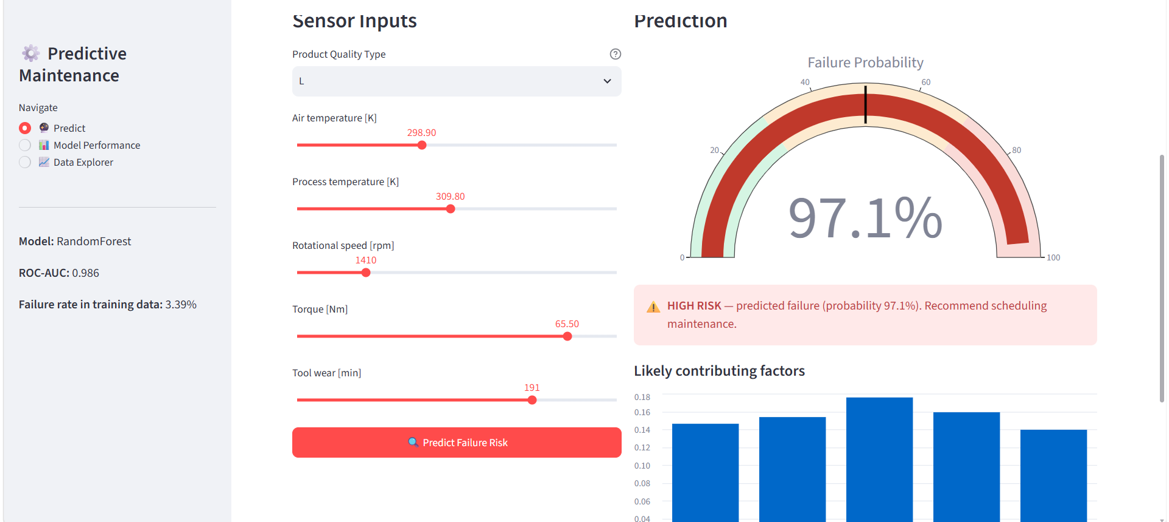
Figure 1: Predict page — a genuine historical failure case correctly flagged at 97.1% risk.
Data Explorer page — failure rate broken down by machine quality type, and the relative frequency of each of the five documented failure modes:
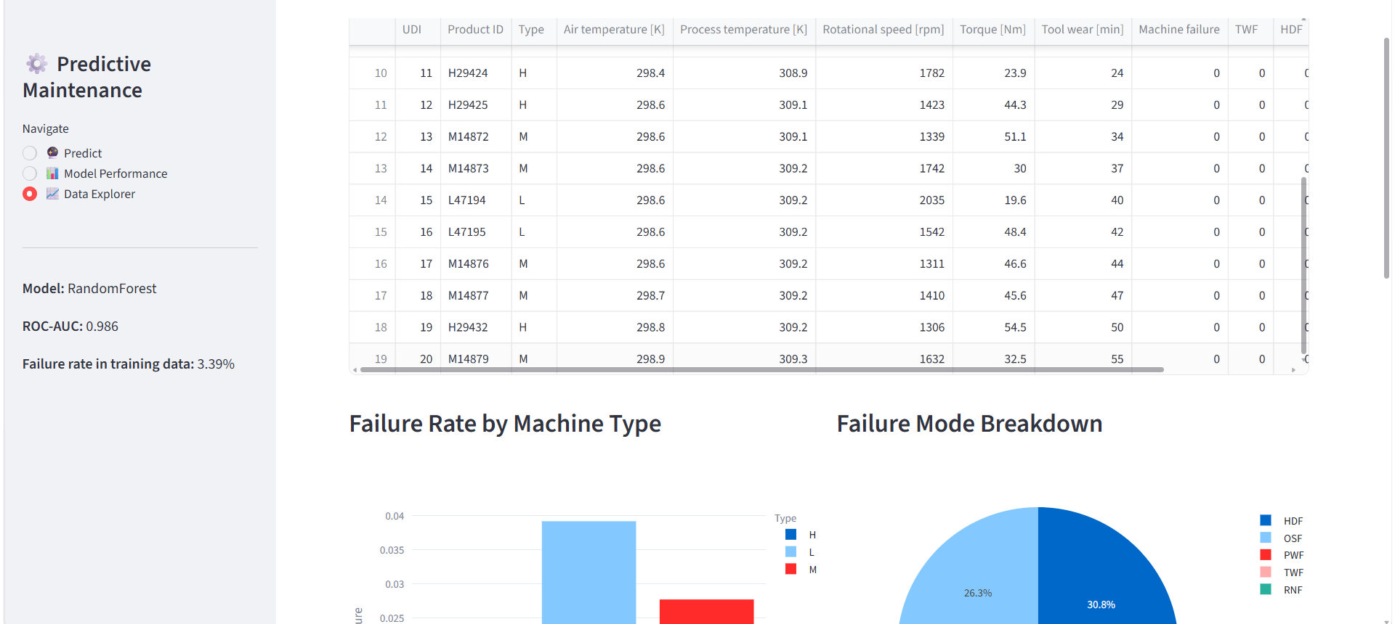
Figure 2: Data Explorer page — failure rate by machine type and failure-mode breakdown.
Project GitHub Link
https://github.com/sure-trust/MAMIDISHETTY-PUJITHA-SHRINIVAS-g38-ai-ml/tree/main/Final%20capstone%20project

Innovation & Entrepreneurship Hub for Educated Rural Youth (SURE Trust – IERY)
Social / Industry Relevance of the Project
Unplanned industrial equipment failure is a direct driver of lost production, wasted materials, and — in sectors like heavy manufacturing — workplace safety incidents caused by equipment operating in a degraded state. Predictive maintenance directly addresses a problem manufacturers already pay for reactively: this project's dataset alone documents machines lost to five distinct mechanical failure modes (tool wear, heat dissipation, power, overstrain, and random failure), each representing a real category of cost.
- Industry relevance: the underlying approach (sensor-driven failure prediction) generalises directly to real IIoT deployments in manufacturing, energy, and heavy equipment sectors, where the same class of sensors (temperature, torque, rotational speed, wear) is already commonly instrumented.
- Economic relevance: unplanned downtime is estimated to cost industry over $50 billion annually worldwide; even incremental improvements in early-warning accuracy translate directly into avoided cost.
- Accessibility relevance: by delivering the model through a dashboard rather than a notebook, the project demonstrates how ML output can be made usable by shop-floor staff without requiring a data-science background — directly relevant to the SURE Trust goal of building industry-ready, employable skills.

Innovation & Entrepreneurship Hub for Educated Rural Youth (SURE Trust – IERY)
Learning and Reflection
New Learnings
- Handling severe class imbalance correctly — understanding why raw accuracy is a misleading metric when only 3.4% of the data represents the class of interest, and why class weighting is a more principled fix than naive oversampling.
- Physics-informed feature engineering — translating domain knowledge about mechanical failure (e.g. torque-to-speed relationships) into features that measurably improved model performance.
- Model validation discipline — going beyond a single train/test split to 5-fold cross-validation, and manually verifying predictions against real historical cases rather than trusting aggregate metrics alone.
- End-to-end delivery — building and deploying an interactive Streamlit dashboard, not just a notebook, including handling model serialization (joblib) and designing a usable UI for a non-technical audience.
Overall Experience
Working through this project end-to-end — from raw sensor data to a validated, deployable dashboard — reinforced that a model's headline accuracy number is only the starting point of a credible ML project. The most valuable part of the process was the validation stage: testing the model against real historical failure records, running cross-validation to check for consistency, and being honest about where the model's recall still falls short. That process of actively trying to find the model's weaknesses, rather than only celebrating its strengths, was the most transferable skill gained from this project.

Innovation & Entrepreneurship Hub for Educated Rural Youth (SURE Trust – IERY)
Conclusion and Future Scope
Recap of Objectives and Achievements
The project set out to predict industrial machine failure from live sensor data, validate that prediction rigorously, and deliver it as a usable tool. All three objectives were met: a Random Forest classifier was trained and deployed with a ROC-AUC of 0.986; its reliability was confirmed via 5-fold cross-validation (AUC 0.979 ± 0.006) and manual verification against a real historical failure case (correctly flagged at 97.1% risk); and the model is delivered through a three-page interactive Streamlit dashboard usable by a non-technical operator.
Honest limitation: recall varies between 65% and 85% across cross-validation folds, meaning that in the worst observed case the model could miss roughly 1 in 3 real failures. For a real deployment, the default 0.5 alert threshold should be lowered to trade some false alarms for higher recall, since missing a genuine failure is costlier than an unnecessary inspection.
Future Scope
- Add an adjustable alert-threshold control to the dashboard, allowing an operator to directly trade off false alarms against recall.
- Extend to a multi-label model that predicts which specific failure mode (TWF / HDF / PWF / OSF) is likely, not just whether a failure will occur.
- Integrate a live sensor stream (e.g. MQTT or Kafka) in place of manual sensor input, enabling real-time monitoring.
- Incorporate continuous time-series sensor logs (rather than one snapshot per machine) to model gradual degradation and estimate remaining useful life, not just a binary failure flag.
Overall, the project demonstrates a complete, defensible predictive-maintenance pipeline — from raw sensor data to a validated, deployable decision-support tool — along with a clear, honest understanding of its current limits and a concrete path to production readiness.

